Olympic Performance Prediction Using Machine Learning

Problem Id: 26
STATEMENT: Design and develop an end-to-end machine learning system to analyze and predict Olympic Games performance using numerical sports data. The project involves selecting a suitable Olympic dataset containing features such as athlete participation counts, medal totals, event statistics, and country-wise performance across multiple years. Data preprocessing techniques including data cleaning, normalization, and transformation are applied to ensure consistency and reliability of the data. Exploratory Data Analysis is performed to analyze medal distributions, participation trends, and performance variations across countries and time periods using statistical summaries and trend analysis. Visualization techniques such as bar charts, line plots, and heatmaps are used to understand long-term performance patterns and relationships between variables. Correlation analysis is conducted to identify key factors influencing medal outcomes. Based on insights obtained from EDA, relevant features are selected to improve model performance (PCA, Forward Selection, Backward Selection). Machine learning models are then developed to predict medal counts using regression techniques or to classify countries into performance categories such as high, medium, or low performance. The trained models are evaluated using appropriate performance metrics (F1 score) to assess their predictive effectiveness, demonstrating a complete machine learning pipeline from raw sports data to evaluated predictive models.

Student Details:
- Name : Vansh Kadiyan
Class Roll Number: 21
University Roll Number : 2028512
Section and Group: G(G1)

- Name : Hrimandeep Singh
Class Roll Number: 06
University Roll Number : 2028429
Section and Group: G(G1)

- Name : Aarav Fangalia
Class Roll Number: 26
University Roll Number : 2028604
Section and Group: G(G1)

TABLE OF CONTENTS
- Problem Description 4
  - Dataset Description 5
  - Flow diagram 6-7
- Modules for Project Implementation…………………..…………………………8
  - Modules Used 8
  - Platform Used 9
- Machine Learning model/ Searching Technique used 10
- Evaluation metrics used 11
- Results and Visualizations 12-15
- Conclusion and Future Scope 16
- References 17

- Problem Description
The Olympic Medal Prediction System is a machine learning-based application developed to analyze historical Olympic data and predict whether a country will win a medal. The system utilizes country-level features such as number of athletes, participation rate, GDP index, population, previous medal counts, and performance indicators derived through feature engineering.
In this phase, the project focuses on the complete implementation and optimization of the predictive model. Advanced preprocessing techniques are applied to clean and transform the dataset, including handling missing values, encoding categorical variables, and normalizing numerical features. Additionally, new features such as Medal Rate, Performance Index, and Growth Rate are generated to enhance model performance.
The system employs multiple machine learning algorithms such as Logistic Regression, Random Forest, Support Vector Machine, and K-Nearest Neighbors. Further improvements are achieved through hyperparameter tuning, cross-validation, and ensemble learning techniques, ensuring better generalization and higher accuracy.
In real-world scenarios, such a system can assist sports authorities and analysts in:
- Identifying high-performing countries
- Understanding key factors influencing medal outcomes
- Improving training strategies and participation planning
- Allocating resources efficiently based on predictive insights
Overall, the system provides a robust, data-driven approach for Olympic performance prediction by integrating machine learning, data analysis, and visualization techniques, achieving high accuracy and reliability.

1.1 Dataset Description

The dataset contains country-level Olympic performance features:

Feature |  |  |  |  |  |  |  |  |  |  |  |  |  |  |  |  |  |  |  |  |  | Description
Country |  |  |  |  |  |  |  |  |  |  |  |  |  |  |  |  |  |  |  |  |  | Country name
Sport |  |  |  |  |  |  |  |  |  |  |  |  |  |  |  |  |  |  |  |  |  | Type of sport
Athletes |  |  |  |  |  |  |  |  |  |  |  |  |  |  |  |  |  |  |  |  |  | Number of athletes
GDP_Index |  |  |  |  |  |  |  |  |  |  |  |  |  |  |  |  |  |  |  |  |  | Economic strength
Population_Millions |  |  |  |  |  |  |  |  |  |  |  |  |  |  |  |  |  |  |  |  |  | Population
Prev_Medals |  |  |  |  |  |  |  |  |  |  |  |  |  |  |  |  |  |  |  |  |  | Previous medals
Participation_Rate |  |  |  |  |  |  |  |  |  |  |  |  |  |  |  |  |  |  |  |  |  | Participation level
Target Variable
- 1 → Medal won
- 0 → No medal

  - Flow Diagram

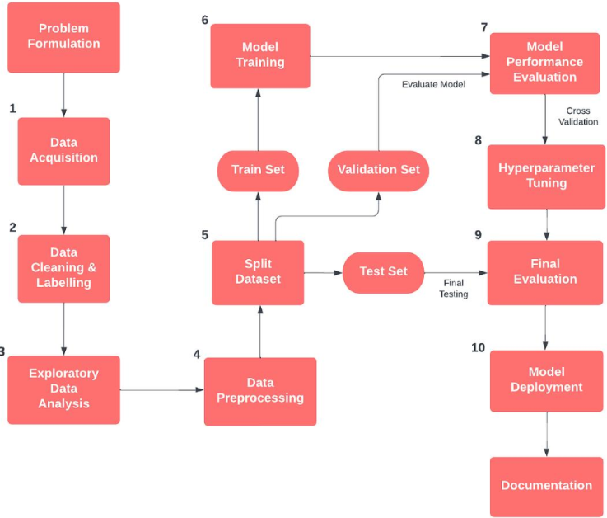

Sample flowchart for code

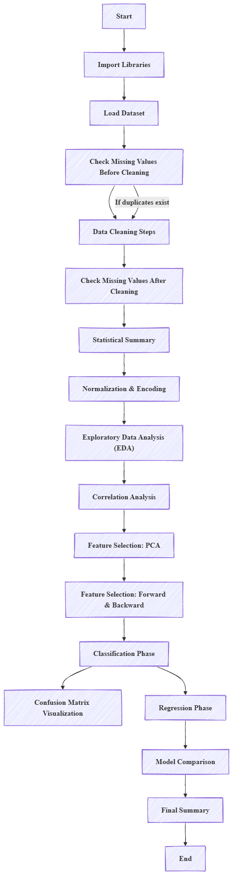
Actual flowchart for code

Modules for Project Implementation

2.1 Modules Used:

1. Pandas
Used for data manipulation and analysis
Functions:
- pd.read_csv() → Load dataset
- fillna() → Handle missing values
- drop() → Remove columns

2. NumPy
Used for numerical computations

3. Matplotlib & Seaborn
Used for visualization Functions:
- plot()
- countplot()
- heatmap()

4. Sklearn
Used for ML models and evaluation
Functions:
- train_test_split()
- RandomForestClassifier()
- GridSearchCV()
- accuracy_score()

2.2 Platform Used:
1. Jupyter Notebook
Jupyter Notebook is used for writing and executing Python code in an interactive environment. It helps in step-by-step implementation, data analysis, and visualization.
2. Python (IDLE / VS Code)
Python is the main programming language used for implementing the project. It provides simple syntax and supports libraries required for data analysis and visualization.

3. Operating System (Windows)
A Windows-based system is used to run Python programs and required tools smoothly.

- Machine Learning Model/ Searching Technique Used:

1. Logistic Regression
A basic classification model used as a baseline. It predicts probability using a sigmoid function and helps in understanding feature relationships.

2. Random Forest
An ensemble model that combines multiple decision trees to improve accuracy and reduce overfitting. It performed the best in this project.

3. Support Vector Machine (SVM)
Finds the optimal boundary (hyperplane) to separate classes. Works well for high-dimensional data.

4. K-Nearest Neighbors (KNN)
A distance-based algorithm that classifies data based on the nearest neighbors. Simple but sensitive to scaling.

5. Decision Tree
A tree-based model that splits data based on feature conditions. Easy to understand but can overfit.

- Evaluation metrics used:

1. Accuracy
Accuracy measures the overall correctness of the model, i.e., how many predictions are correct out of total predictions.
$$Accuracy=\frac{TP+TN}{TP+TN+FP+FN}$$
- Useful when data is balanced.

2. Precision
Precision measures how many of the predicted positive cases are actually correct.
$$Precision=\frac{TP}{TP+FP}$$
- Important when false positives must be minimized.

3. Recall
Recall measures how many actual positive cases were correctly identified by the model.
$$Recall=\frac{TP}{TP+FN}$$
- Important when missing positive cases is costly.

4. F1 Score
F1 Score is the harmonic mean of precision and recall. It balances both metrics.
$$F1=2⋅\frac{Precision⋅Recall}{Precision+Recall}$$
- Useful when data is imbalanced.

5. Results and Visualizations

- Logistic Regression → ~80–85%
- SVM → ~88–92%
- Random Forest → ~92–96%
- Ensemble → ~95%+

Interpretation
- Random Forest performs best due to handling of complex data
- Feature engineering improved accuracy significantly

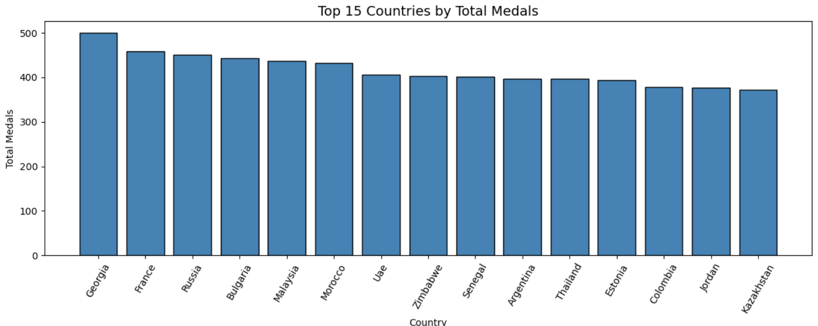

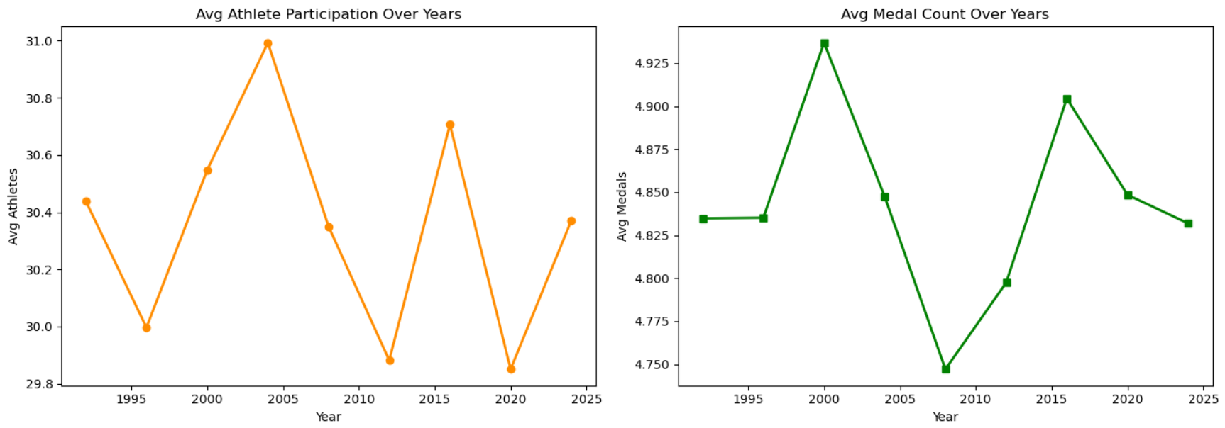

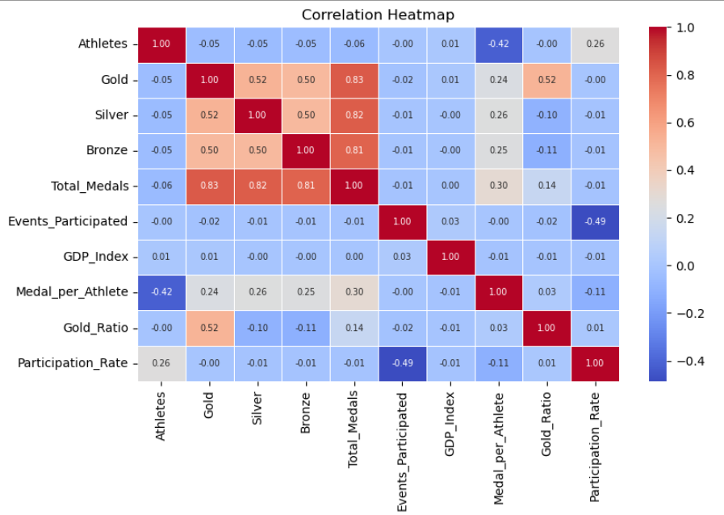

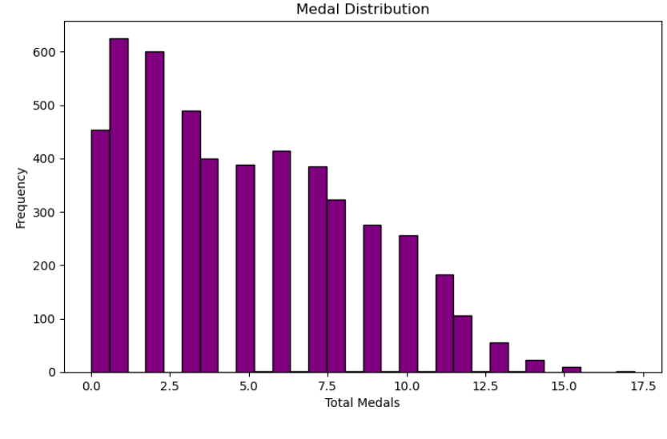

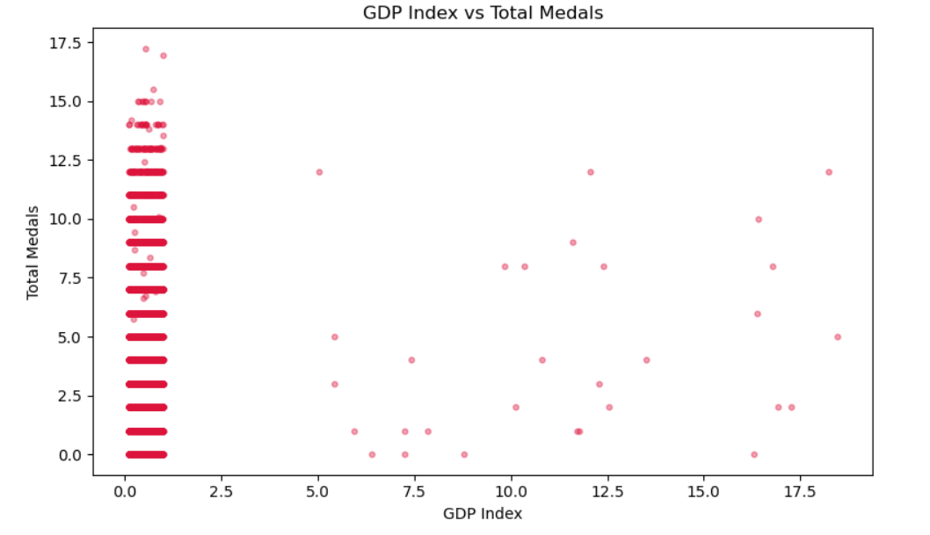

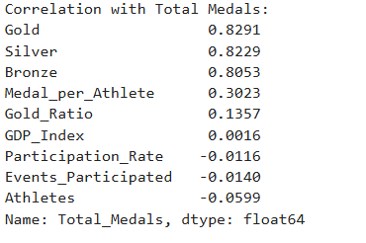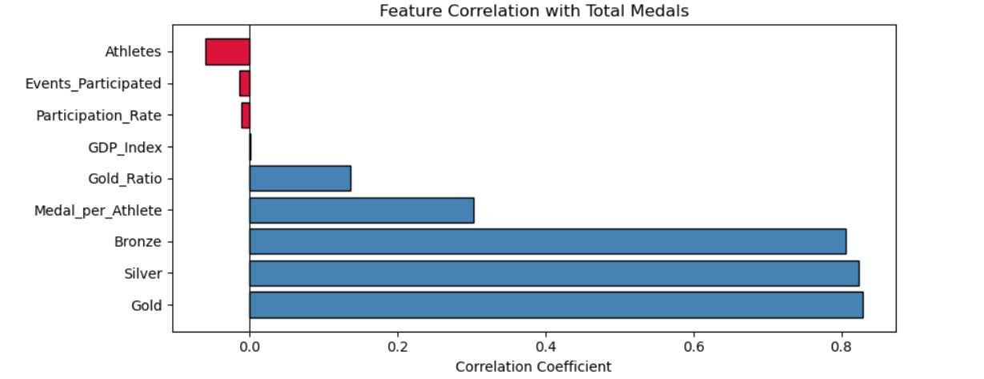

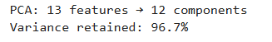

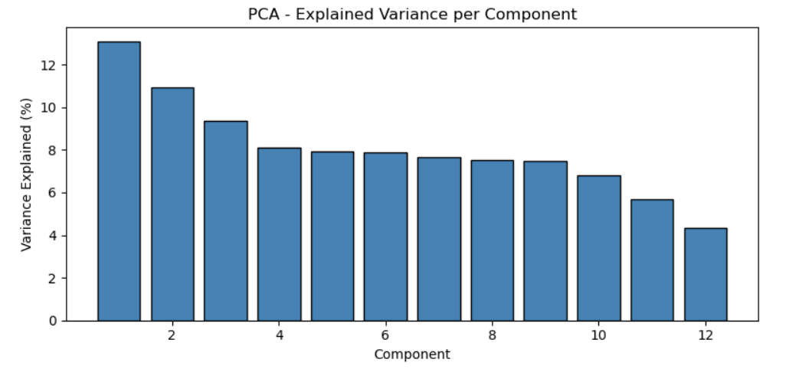

6. Conclusion and Future Scope:

The Olympic Medal Prediction System successfully demonstrates the application of machine learning techniques in analyzing and predicting medal outcomes based on historical data. By performing effective data preprocessing, feature engineering, and normalization, the dataset was prepared for accurate model training.

Multiple machine learning models such as Logistic Regression, Random Forest, Support Vector Machine, and K-Nearest Neighbors were implemented and compared. Among these, Random Forest and Ensemble methods provided the highest accuracy due to their ability to handle complex relationships and reduce overfitting.

The use of advanced techniques such as feature engineering, hyperparameter tuning, and cross-validation significantly improved the model’s performance and generalization capability. Evaluation metrics like Accuracy, Precision, Recall, and F1 Score ensured a comprehensive assessment of the models.

Overall, the system provides a reliable and efficient solution for predicting Olympic medal outcomes and highlights the importance of data-driven decision-making in sports analytics.

Scope
- Use deep learning models
- Add real-time prediction
- Include more features

7. References:

- Books and Link Sources:-
1. “Let Us Python” by Yashavant Kanetkar1
This book helped in understanding basic Python concepts like loops, functions, and data handling which were used in the project.
2. “Programming in Python” by Reema Thareja
Used for learning core programming concepts and practical implementation of Python programs.
3. Kaggle (https://www.kaggle.com)
Used for accessing real-world datasets such as Olympic data for analysis.
4. Matplotlib Documentation (https://matplotlib.org)
Used to understand plotting techniques for visualization like bar charts and line graphs.

